Project Design Phase-II
Technology Stack (Architecture & Stack)

Date | 18 june 2026
Team ID
Project Name | SHOPEZ – E-Commerce Web Application
Maximum Marks | 4 Marks

Technical Architecture:
The Deliverable shall include the architectural diagram as below and the information as per the table1 & table 2
Example: Order processing during pandemics for offline mode
Reference: https://developer.ibm.com/patterns/ai-powered-backend-system-for-order-processing-during-pandemics/

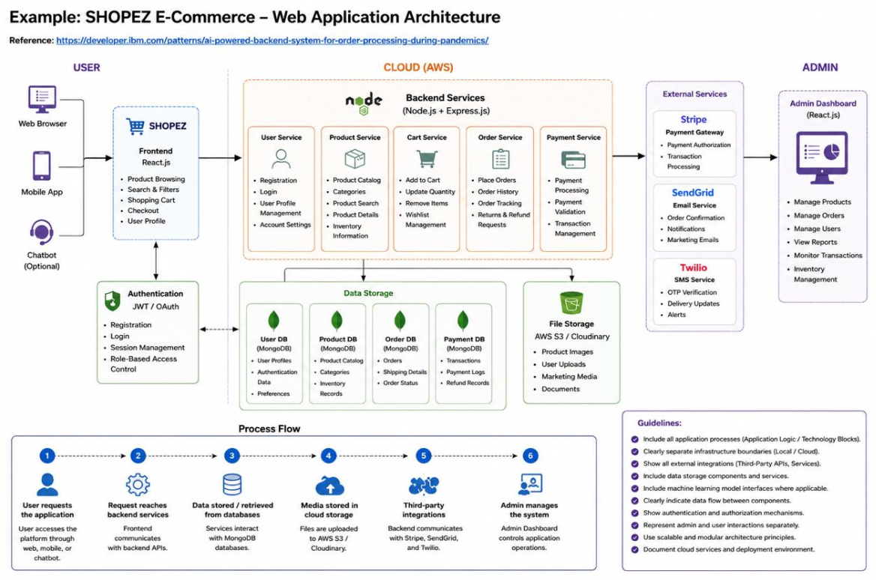
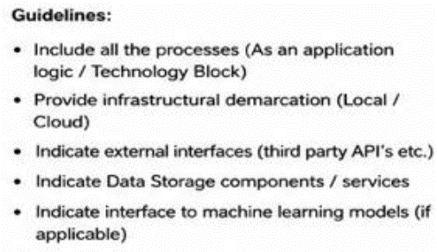

Table-1 : Components & Technologies
S.No | Component | Description | Technology
1 | User Interface | Customer & Admin Web Interface | React.js, HTML5, CSS3, JavaScript
2 | Application Logic-1 | Authentication & Authorization | Node.js, Express.js, JWT
3 | Application Logic-2 | Product & Cart Management | Node.js, Express.js
4 | Application Logic-3 | Order Processing & Checkout | Node.js, Express.js
5 | Database | Stores Users, Products, Orders | MongoDB
6 | Cloud Database | Cloud-hosted Database | MongoDB Atlas
7 | File Storage | Product Images & Media Files | Cloudinary / Local Storage
8 | External API-1 | Payment Gateway Integration | Stripe API
9 | External API-2 | Email Notifications | Nodemailer / Gmail SMTP
10 | Machine Learning Model | Not Applicable | N/A
11 | Infrastructure | Application Deployment | Vercel (Frontend), Render/Railway (Backend), MongoDB Atlas

Table-2 : Application Characteristics
S.No | Characteristics | Description | Technology
1 | Open Source Frameworks | Frameworks used in development | React.js, Node.js, Express.js, MongoDB
2 | Security Implementations | Authentication, Password Encryption, Access Control | JWT, bcrypt, HTTPS, OWASP Practices
3 | Scalable Architecture | Three-tier architecture supporting future growth | React + Node + MongoDB
4 | Availability | Application accessible 24/7 through cloud deployment | Vercel, Render, MongoDB Atlas
5 | Performance | Fast API response and optimized database queries | Express.js, MongoDB Indexing, Caching

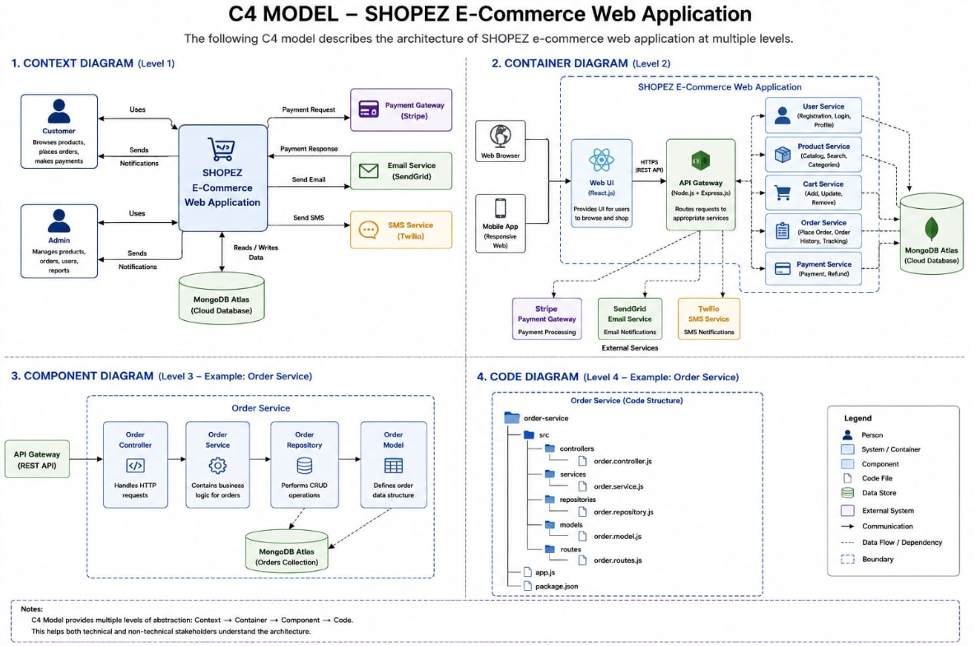

References:
https://c4model.com/
https://developer.ibm.com/patterns/online-order-processing-system-during-pandemic/
https://www.ibm.com/cloud/architecture
https://aws.amazon.com/architecture
https://medium.com/the-internal-startup/how-to-draw-useful-technical-architecture-diagrams-2d20c9fda90d

